Documentation
STUDENT ID:C00305107
DATE: 15/02/2025

Class diagram
FallingObjectGame
- WIDTH: int
- HEIGHT: int
- BASKET_WIDTH: int
- BASKET_HEIGHT: int
- OBJECT_SIZE: int
- FALL_SPEED: int
- basketX: int
- score: int
- objects: ArrayList<FallingObject>
- timer: Timer
- rand: Random
FallingObjectGame()

paintComponent(Graphics)

actionPerformed(ActionEvent)

restartGame()

FallingObject
- x: int
- y: int
- isGood: boolean
FallingObject(int, int, boolean)

Project Approach:
- Used Swing for GUI and Timer for animation.
- Implemented composition by using FallingObject inside FallingObjectGame.
- Introduced randomized mechanics for enhanced gameplay.
- Improved event handling and graphics rendering.
- Understood randomization and collision detection.
- Ensured objects are correctly removed when caught or missed.
- Adjusted fall speed for a balanced gameplay experience.
- Added mouse click functionality to restart the game.
- Score calculation:
  - Good objects: +10 points
  - Bad objects: -10 points

Screenshot of game:
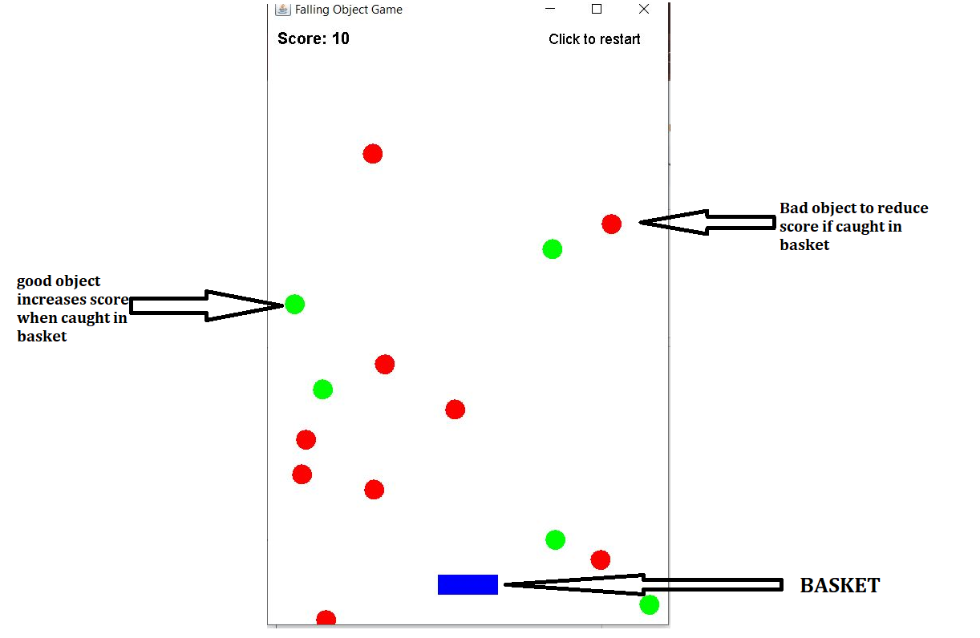

Final Notes
This document provides an overview of the Falling Object Game implemented in Java Swing, including a class diagram, project approach, and core functionalities. The game allows users to control a basket to catch falling objects, track scores, and restart the game by clicking the mouse. This project enhances understanding of event-driven programming, GUI development, and object management in Java.

